OS (Operating System) is system software that acts as an interface between the user and the computer hardware.
What does an Operating System do?
An OS manages all the resources of a computer and provides services to applications.
Main Functions of an OS
Function | Description
Process Management | Creates, schedules, and terminates processes.
Memory Management | Allocates and deallocates RAM to programs.
File Management | Organizes files and directories.
Device Management | Controls hardware devices like printers, keyboards, and disks.
Security | Provides authentication and access control.
User Interface | Offers a graphical interface (GUI) or command-line interface (CLI).
Types of Operating Systems
- Batch Operating System
- Time-Sharing Operating System
- Distributed Operating System
- Network Operating System
- Real-Time Operating System (RTOS)
- Mobile Operating System
Examples of Operating Systems
Microsoft Windows
Ubuntu
macOS
Android
iOS
Simple Diagram
User
↓
Applications
↓
Operating System
↓
Hardware
In Linux (useful for DevOps)
Common commands to check OS information:
uname -a # Kernel and system information
cat /etc/os-release # Linux distribution details
hostnamectl # Hostname and OS details
Example output:
$ cat /etc/os-release
NAME="Ubuntu"
VERSION="24.04 LTS"
ID=ubuntu
For DevOps interviews, remember:
Operating System = Resource Manager + Interface between Users/Applications and Hardware.
An Operating System (OS) is used because computers cannot work efficiently without software to manage their hardware and resources.
Why is an OS used?
1. To run applications
The OS provides an environment where programs can execute.
Example:
- You open a web browser.
- The OS loads it into memory and gives it CPU time to run.
2. To manage the CPU
Many programs may run at the same time. The OS decides which program gets the CPU and for how long.
Example:
- Listening to music while editing a document.
3. To manage memory (RAM)
The OS allocates memory to programs and frees it when they finish.
Example:
- A browser may use 2 GB of RAM, while a text editor uses only 100 MB.
4. To manage files
The OS organizes files and folders on storage devices.
Example:
- Creating a folder named Documents
- Saving a file as notes.txt
5. To control hardware devices
The OS communicates with devices such as:
- Keyboard
- Mouse
- Printer
- Hard disk
- Network card
6. To provide security
The OS protects the system through:
- User accounts
- Passwords
- File permissions
7. To provide a user interface
The OS lets users interact with the computer through:
- GUI (Graphical User Interface) – windows, icons, menus
- CLI (Command Line Interface) – commands typed in a terminal
Simple analogy
Think of a computer as a company:
Component | Analogy
Hardware | Employees and machines
Applications | Different departments
Operating System | The manager coordinating everything
User | The company owner
Without an OS:
- Programs cannot run.
- Hardware cannot be managed properly.
- Users would have to communicate directly with hardware, which is very difficult.
In one sentence:
An Operating System is used to manage computer resources and provide an easy way for users and applications to interact with hardware.
Linux is popular because it is free, secure, stable, and highly customizable. These qualities make it the preferred choice for servers, cloud computing, and DevOps.
1. Free and Open Source
- Linux can be downloaded and used without paying license fees.
- Anyone can view, modify, and distribute its source code.
2. High Security
- Linux has strong permission and ownership systems.
- Viruses and malware are less common compared to some other operating systems.
- Security updates are released frequently.
3. Stability and Reliability
- Linux systems can run for months or even years without needing a reboot.
- It is widely used for critical services such as websites and databases.
4. Excellent Performance
- Linux uses system resources efficiently.
- It can run smoothly even on older hardware.
5. Customization
- Users can choose different desktop environments and distributions.
- You can customize almost every part of the system.
Examples of Linux distributions:
- Ubuntu
- Debian
- Fedora
- Arch Linux
6. Dominates Servers and Cloud
- Most web servers run Linux.
- Major cloud providers support Linux extensively.
Examples:
- Amazon Web Services
- Google Cloud
- Microsoft Azure
7. Essential for DevOps
Many DevOps tools work best on Linux, such as:
- Docker
- Kubernetes
- Jenkins
Quick Comparison
Feature | Linux | Windows
Cost | Free | Usually Paid
Source Code | Open | Closed
Security | High | Moderate
Customization | Very High | Limited
Server Usage | Very Common | Less Common
For a DevOps Engineer
Learning Linux is important because:
- Most cloud servers use Linux.
- Automation scripts are commonly written for Linux environments.
- Many DevOps interviews include Linux command questions.
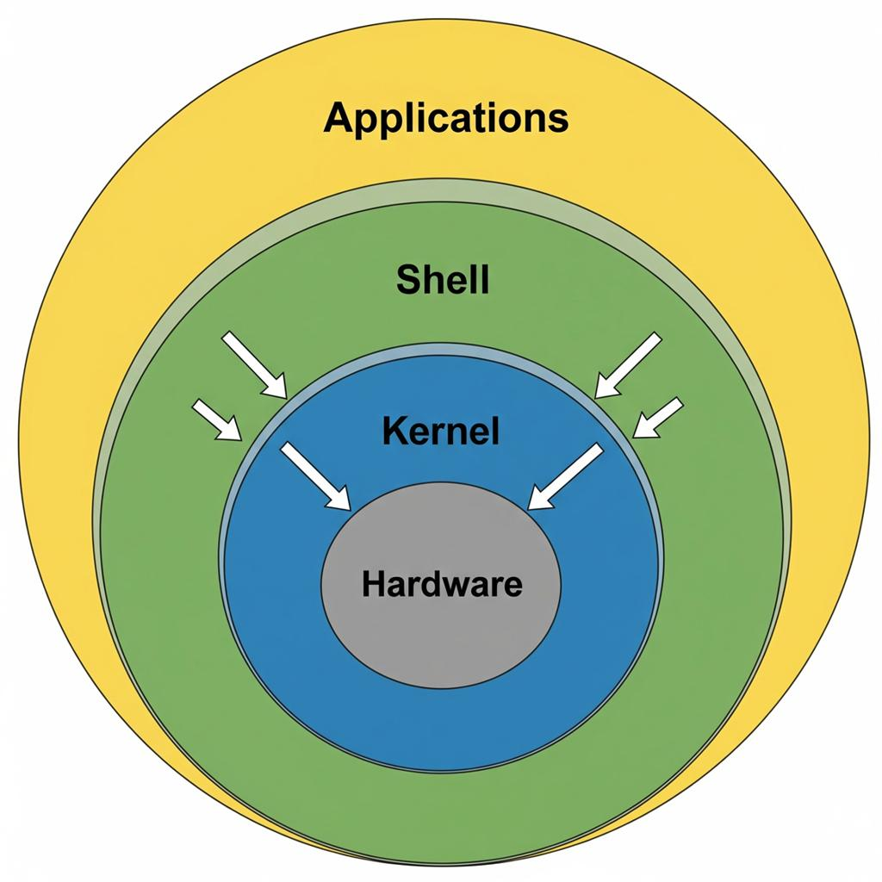
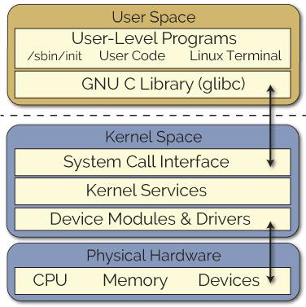
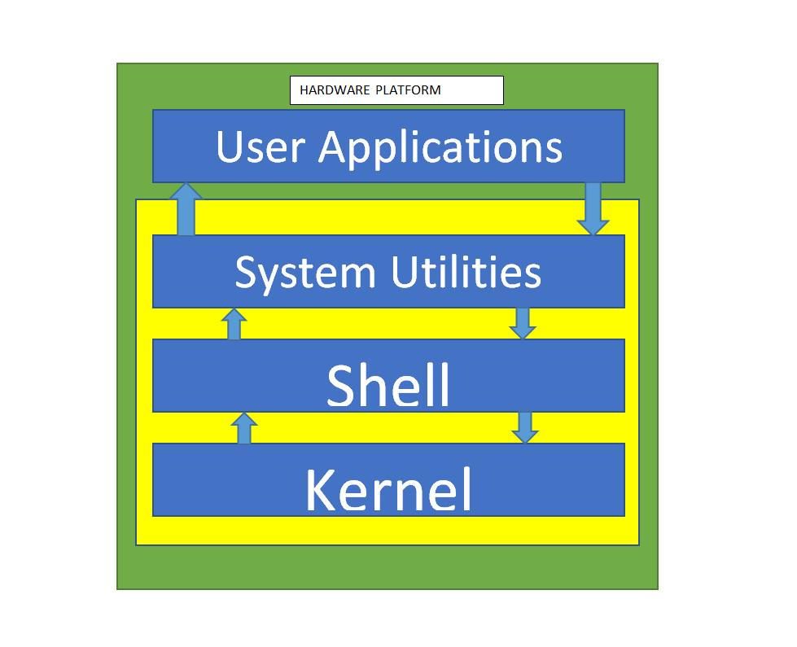
4
Linux Architecture
Linux architecture is divided into 4 main layers.
+----------------------+
| User Applications |
+----------------------+
| Shell |
+----------------------+
| Kernel |
+----------------------+
| Hardware |
+----------------------+
1. Hardware Layer
This is the physical part of the computer.
Examples:
- CPU
- RAM
- Hard Disk/SSD
- Keyboard
- Network Card
The hardware does not directly interact with users or applications.

2. Kernel Layer
The kernel is the core of Linux. It acts as a bridge between applications and hardware.
Functions of the Kernel
Function | Description
Process Management | Creates and schedules processes
Memory Management | Allocates and frees RAM
Device Management | Controls hardware devices
File System Management | Handles files and directories
Network Management | Manages network communication
Security | Enforces permissions and access control
Example:
When you run:
cat file.txt
The kernel:
- Receives the request.
- Reads the file from disk.
- Sends the data back to the terminal.

3. Shell Layer
The shell is a command interpreter.
It accepts commands from the user and sends them to the kernel.
Common shells:
- Bash
- Zsh
- KornShell
Example:
ls -l
The shell interprets ls -l, asks the kernel for directory information, and displays the result.

4. User Applications Layer
These are programs used by users.
Examples:
- Text editors
- Web browsers
- Databases
- DevOps tools
Examples include:
- Docker
- Jenkins
- Git

How Linux Works
Suppose you type:
mkdir test
Flow of execution:
User
↓
Shell (Bash)
↓
Kernel
↓
Hard Disk
↓
Directory "test" Created
Linux Architecture Explained
+------------------------------------------------+
| System Software | User Process | Utilities |
| Compilers |
+------------------------------------------------+
| System Libraries |
+------------------------------------------------+
| Kernel |
+------------------------------------------------+
| Kernel Modules |
+------------------------------------------------+
| Hardware (CPU, RAM, I/O) |
+------------------------------------------------+

1. System Software, User Process, User Utilities, Compilers
These are programs that users interact with.
System Software
Software that helps manage the system.
Examples:
- systemd
- cron
- Package managers (apt, yum)
User Process
Programs currently running.
Examples:
firefox
nginx
python app.py
You can see running processes using:
ps -ef

User Utilities
Small tools provided by Linux.
Examples:
ls
cp
mv
mkdir
cat
grep
Example:
mkdir test
creates a directory.

Compilers
Convert source code into executable programs.
Examples:
- gcc → C compiler
- g++ → C++ compiler
Example:
gcc hello.c -o hello

2. System Libraries
System libraries provide pre-written functions that applications use.
Examples:
- glibc
- libpthread
- libm
Example:
When a C program calls
printf("Hello");
it actually uses a function from the C library.
Applications do not directly talk to the kernel. They use libraries, and libraries communicate with the kernel.

3. Kernel
The kernel is the heart of Linux.
Responsibilities:
Task | Description
Process Management | Manages processes
Memory Management | Controls RAM
File Systems | Handles files
Networking | Manages network traffic
Security | Permissions and access control
Example:
When you run
cat file.txt
the kernel reads the file from disk and returns its contents.

4. Kernel Modules
Kernel modules are pieces of code that can be loaded into the kernel when needed.
Examples:
- USB drivers
- Wi-Fi drivers
- Filesystem drivers
Advantages:
- No need to rebuild the kernel.
- Modules can be loaded or removed dynamically.
Commands:
lsmod # List loaded modules
modprobe usb_storage
rmmod usb_storage

5. Hardware
This is the physical equipment.
Examples:
- CPU
- RAM
- SSD/HDD
- Keyboard
- Mouse
- Network Card

Complete Flow Example
Suppose you execute:
mkdir demo
What happens?
- User Utility
  - mkdir command starts.
- System Library
  - mkdir() library function is called.
- Kernel
  - Kernel checks permissions.
  - Kernel creates the directory entry.
- Kernel Module
  - Filesystem driver (like ext4) handles the disk operation.
- Hardware
  - SSD/HDD stores the new directory.
GNU/Linux
GNU/Linux refers to the combination of the GNU operating system components and the Linux kernel.
Many people simply say Linux, but technically most Linux distributions are GNU/Linux because they include both GNU software and the Linux kernel.
What is GNU?
GNU Project
GNU stands for:
GNU's Not Unix
It was started in 1983 by Richard Stallman to create a free Unix-like operating system.
GNU provides many essential tools:
Examples:
- Bash Shell
- GCC Compiler
- Core utilities (ls, cp, mv, cat)
- glibc (C library)

What is Linux?
Linus Torvalds created the Linux kernel in 1991.
The Linux kernel is responsible for:
- Process management
- Memory management
- Device drivers
- File systems
- Networking

GNU + Linux = GNU/Linux
GNU Components
(Bash, GCC, ls, cp, glibc)
+
Linux Kernel
=
GNU/Linux Operating System
Example
When you run:
ls -l
- ls is a GNU utility
- bash is a GNU shell
- The Linux kernel handles the request to access files and directories

Why do people usually say "Linux"?
It is shorter and more common.
Examples:
People say:
- "I use Linux."
Technically:
- "I use GNU/Linux."

Examples of GNU/Linux Distributions
- Ubuntu
- Debian
- Fedora
- Rocky Linux
Interview Question
Q: Why is Linux sometimes called GNU/Linux?
Answer: Because the complete operating system consists of the Linux kernel plus the GNU tools, libraries, and utilities that make the system usable. Without GNU tools, the Linux kernel alone is not a complete operating system.
VIM Editor in Linux
Vim (Vi Improved) is a powerful text editor used in Linux and Unix systems to create and edit files.
It is an improved version of the older vi editor.
Why is Vim used?
- Available on almost all Linux systems
- Lightweight and fast
- Useful for editing configuration files
- Widely used by Linux administrators and DevOps engineers
Examples of files edited with Vim:
/etc/nginx/nginx.conf
/etc/ssh/sshd_config
~/.bashrc

Opening a File
Open an existing file:
vim file.txt
Create a new file:
vim newfile.txt

Vim Modes
Vim has three main modes.
1. Normal Mode
This is the default mode when Vim starts.
Used for:
- Moving around
- Copying text
- Deleting text
Example commands:
h → left
l → right
j → down
k → up

2. Insert Mode
Used for typing and editing text.
To enter Insert Mode:
i
Other ways:
a → insert after cursor
o → open a new line below
O → open a new line above
To return to Normal Mode:
Esc

3. Command Mode
Press Esc and then type : to enter command mode.
Common commands:
Command | Meaning
:w | Save file
:q | Quit
:wq | Save and quit
:q! | Quit without saving
:x | Save and exit

Useful Vim Commands
Command | Action
yy | Copy current line
dd | Delete current line
p | Paste
u | Undo
Ctrl + r | Redo
/word | Search for a word
n | Next search result
G | Go to last line
gg | Go to first line

Example Session
vim notes.txt
- Press i → Enter Insert Mode
- Type:
Hello World
Linux is awesome
- Press Esc
- Type:
:wq
- Press Enter
The file is saved and Vim exits.

Interview Question
Q: What are the three modes of Vim?
Answer:
- Normal Mode – Navigation and commands
- Insert Mode – Editing text
- Command Mode – Saving, quitting, and executing commands
Quick Cheat Sheet
vim file.txt → Open file
i → Insert mode
Esc → Normal mode
:w → Save
:q → Quit
:wq → Save and quit
:q! → Quit without saving
dd → Delete line
yy → Copy line
p → Paste
How to Use Vim (Step by Step)
Vim may look confusing at first because it has different modes. Once you learn the basics, it becomes very powerful.

Step 1: Open Vim
Create a new file or open an existing file:
vim myfile.txt
You will see an empty screen or the contents of the file.

Step 2: Enter Insert Mode
When Vim opens, it starts in Normal Mode.
To start typing, press:
i
You should see -- INSERT -- at the bottom.
Now type some text:
Hello World
Welcome to Vim

Step 3: Exit Insert Mode
After typing, press:
Esc
You are now back in Normal Mode.

Step 4: Save the File
Type:
:w
Then press Enter.
This saves the file.

Step 5: Quit Vim
To quit Vim:
:q
Press Enter.

Step 6: Save and Quit Together
Instead of saving and quitting separately, use:
:wq
or simply:
:x

Step 7: Quit Without Saving
If you made changes and don't want to keep them:
:q!

Complete Example
Open a file
vim test.txt
Press
i
Type
Linux
AWS
DevOps
Press
Esc
Save and exit
:wq
Press Enter

Useful Vim Commands
Command | Action
i | Insert before cursor
a | Insert after cursor
o | New line below
Esc | Return to Normal Mode
dd | Delete current line
yy | Copy current line
p | Paste copied line
u | Undo
Ctrl+r | Redo
/word | Search for a word
gg | Go to first line
G | Go to last line

Practice Exercise
Try these commands one by one:
vim demo.txt
Press:
i
Type:
I am learning Linux.
Vim is powerful.
Press:
Esc
Type:
yy
p
This will copy and paste the current line.
Finally:
:wq
Press Enter.
You have now created, edited, copied text, and saved a file using Vim.
The command you wrote:
rm -r
uses the rm (remove) command with the -r (recursive) option.
What does -r mean?
-r stands for recursive.
It tells rm to delete a directory and everything inside it, including:
- Files
- Subdirectories
- Their contents
Syntax
rm -r directory_name
Example
Create a directory:
mkdir test
touch test/file1.txt
mkdir test/subdir
touch test/subdir/file2.txt
Directory structure:
test/
├── file1.txt
└── subdir/
└── file2.txt
Delete it:
rm -r test
Now test and all its contents are removed.

Difference between rm, rm -r, and rm -rf
Command | Purpose
rm file.txt | Delete a file
rm -r dir | Delete a directory and its contents
rm -rf dir | Force delete a directory and its contents without asking
Example
rm myfile.txt # Delete a file
rm -r myfolder # Delete a folder recursively
rm -rf myfolder # Force delete a folder recursively
⚠️ Warning
Be very careful with:
rm -rf /
This attempts to delete the entire filesystem and can destroy the system.
Interview Question
Q: Why can't we use rm folder_name to delete a directory?
A: Because rm deletes files by default. To delete a directory and its contents, we must use the -r option.
Tip: Before deleting, you can check what's inside a directory using:
ls -R directory_name
This lists all files and subdirectories recursively.
nproc Command in Linux
The nproc command is used to display the number of processing units (CPU cores) available to the current process.
Syntax
nproc
Example
$ nproc
4
This means your system has 4 CPU cores available.

Why is nproc useful?
It helps determine how many CPU cores are available for running applications, compiling programs, or parallel processing.
Examples:
Check CPU cores
nproc
Output:
8
Meaning: The system can use 8 CPU cores.

Related Commands
Command | Purpose
nproc | Show available CPU cores
lscpu | Display detailed CPU information
cat /proc/cpuinfo | Show complete CPU details
top | Monitor CPU and memory usage in real time
Example: Detailed CPU Information
lscpu
Sample output:
CPU(s): 8
Thread(s) per core: 2
Core(s) per socket: 4
Socket(s): 1

DevOps Usage
When compiling software, you can use all available cores to speed up the process:
make -j$(nproc)
Explanation:
- $(nproc) gets the number of CPU cores.
- -j tells make to run jobs in parallel.
If nproc returns 8, then:
make -j8
will run 8 compilation jobs simultaneously, making the build faster.
Interview Question
Q: What does nproc do?
Answer:
nproc displays the number of CPU processing units (cores) available to the current process.
Linux Monitoring Commands
Monitoring commands help you check the CPU, memory, disk, network, and running processes in a Linux system.
1. top – Real-time System Monitoring
top
Shows:
- CPU usage
- Memory usage
- Running processes
- Load average
Example:
top - 10:30:45 up 2 days, 3:15, 2 users
Tasks: 210 total
%Cpu(s): 12.5 us, 3.0 sy
MiB Mem : 3900 total, 1200 free
Press q to quit.

2. htop – Interactive Process Viewer
htop
Features:
- Colorful interface
- Scroll through processes
- Kill processes interactively
If not installed:
sudo apt install htop

3. free -h – Memory Usage
free -h
Example:
Mem: 3.8Gi 1.5Gi 900Mi 1.4Gi
Swap: 2.0Gi 0B 2.0Gi

4. df -h – Disk Space Usage
df -h
Example:
Filesystem Size Used Avail Use%
/dev/sda1 50G 20G 28G 42%

5. du -sh – Directory Size
du -sh folder_name
Example:
du -sh /var/log

6. ps – Running Processes
ps -ef
Example:
ps -ef | grep nginx

7. vmstat – CPU and Memory Statistics
vmstat 2
Updates every 2 seconds.

8. iostat – Disk I/O Statistics
iostat
Install if missing:
sudo apt install sysstat

9. sar – Historical Performance Data
sar -u 1 5
Shows CPU utilization every second for 5 times.

10. uptime – System Uptime and Load
uptime
Example:
10:45:12 up 5 days, 3 users, load average: 0.25, 0.30, 0.28

11. nproc – CPU Core Count
nproc
Example:
4
Means the system has 4 CPU cores.

12. netstat or ss – Network Monitoring
ss -tulnp
Shows:
- Listening ports
- Active connections
- Process IDs

Most Important Commands for DevOps Interviews
Resource | Command
CPU Usage | top
Memory Usage | free -h
Disk Usage | df -h
Directory Size | du -sh
Processes | ps -ef
CPU Cores | nproc
Network Ports | ss -tulnp
Uptime | uptime
Quick Health Check Commands
top
free -h
df -h
uptime
nproc
ss -tulnp
These six commands are commonly used by Linux administrators and DevOps engineers to quickly assess a server's health.

